Hart Publishing is delighted to give you information about their latest title

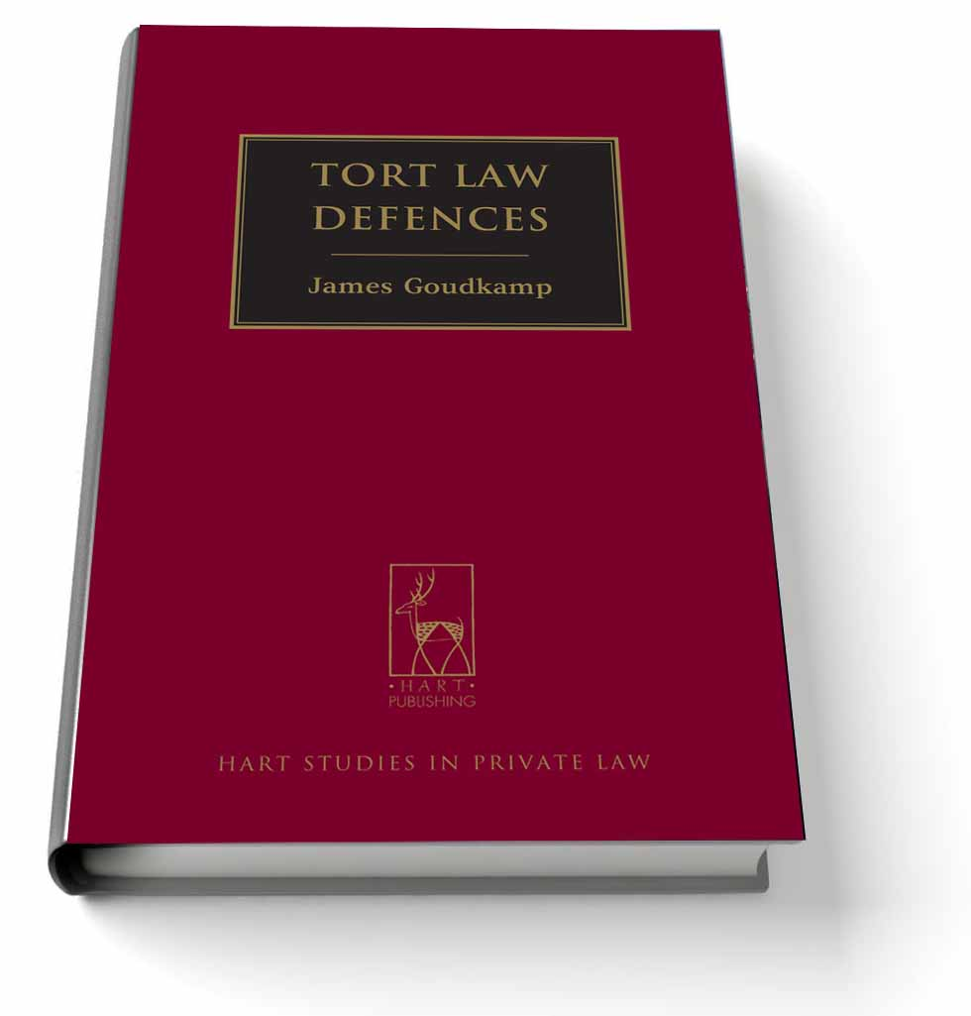
Tort Law Defences
By James Goudkamp

The law of torts recognises many defences to liability. While some of these defences have been explored in detail, scant attention has been given to the theoretical foundations of defences generally. In particular, no serious attempt has been made to explain how defences relate to each other or to the torts to which they pertain. The goal of this book is to reduce the size of this substantial gap in our understanding of tort law. The principal way in which it attempts to do so is by developing a taxonomy of defences. The book shows that much can be learned about a given defence from the way in which it is classified.

James Goudkamp is a Fellow of Balliol College, Oxford, and a Lecturer in the Oxford Law Faculty. He holds or has held visiting positions at Harvard Law School, the National University of Singapore, the University of Western Australia and the University of Wollongong.

Please click here to view the table of contents for this book

July 2013 268pp Hbk 9781849462914 RSP: £60 / €78
Discount Price: £48 / €62.40

As a member of the Obligations Discussion Group Hart Publishing is delighted to offer you 20% discount.
ORDER ON-LINE
Please click here to order online. When ordering online please type the reference 'ODG' in the voucher code field and click ‘apply’ to receive the discount.

Alternatively, please contact Hart Publishing and quote reference ‘ODG’ to receive the 20% discount.
Hart Publishing Ltd, 16C Worcester Place Oxford OX1 2JW, UK
Tel: +44 (0)1865 517530 Fax: +44 (0)1865 510710
E-mail: mail@hartpub.co.uk; Website: http://www.hartpub.co.uk

